We Google Everything

Joseph Birch

Nithin Huliyappa

Anant Paradkar

Priyanka Pradeep Rane

Deekansha Tandon

Adwait Tathe

**EventLite Summary**

The EventLite application is design to help users locate, connect and learn more about local events in a given area. EventLite offers a search feature that allows our users to search for events based on criteria we provide to them to display local events. EventLite allows the users to login/register using our own login fields or the user can login using Facebook. EventLite is designed to connect users who are attending the same events. The search results page display the event results based on the criteria the user has enter. Once the user clicks on the event, it display information about the event along with a Google Map view of where the event is located. If the user wants to register for the event, they can click the Register button on the event page and this information would be displayed in the MyEvents page which is user specific. The user will also receive a text message after they have registered for the event.

Our group utilized an EC2 instance to deploy our application and used other Amazon services to help create our application. Cognito was used for our authenticating our users who login to the application. DynamoDB allowed us to store our event data and our user data. Our team integrated Twilio to be able to send communications to our users. Also Twilio will send a text message to the user confirming they have registered for an event once the Register once the user has clicked on an event they are interested in attending.

*List of AWS services and API used*

1. AWS EC2
2. AWS DynamoDB
3. AWS Cognito
4. Google Maps
5. Twilio

*Steps to run the Application*

1) UnZip the file

2) Unzipped folder contain the source code and SSH file to login to EC2 instance

3) Use Putty to login to EC2 instance

4) Enter Host name as [**ec2-user@ec2-54-157-252-80.compute-1.amazonaws.com**](mailto:ec2-user@ec2-54-157-252-80.compute-1.amazonaws.com)

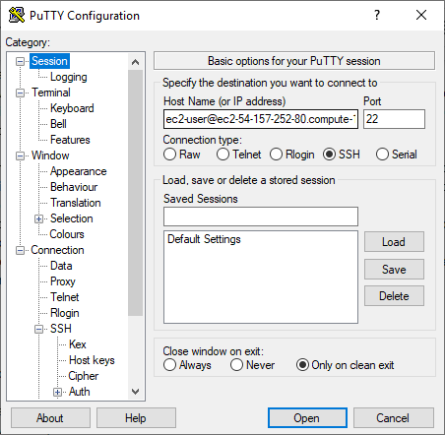

5) In putty category window, select SSH>>Auth and browse .ppk file and click on open

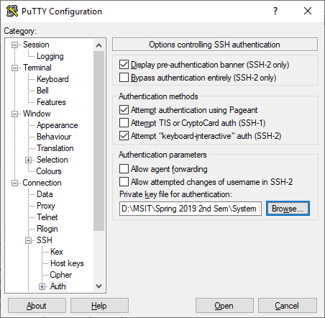

3) Issue “cd EventWebApp” once you successfully login to EC2 instance

4) Issue "node app" command to start the application

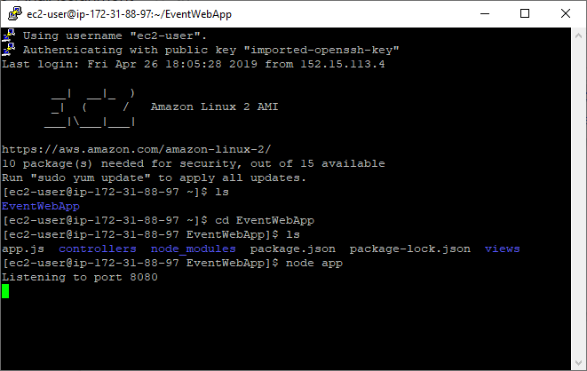

6) Enter <http://ec2-54-157-252-80.compute-1.amazonaws.com:8080/index> in your browser to access our application.

7) Use below credentials to login to our application if you don’t want to sign up

Email :

Password:

8) After a successful login, you will redirected to https link, since we have issue with https on EC2 instance, go to address bar and remove s from https and hit enter to land in search.

9) Event data is populated in the DynamoDB already, so you don’t have to run any scripts to test the application.